**1**

ATUSS – ODSEK VISOKA ŠKOLA ZA INFORMACIONE I KOMUNIKACIONE TEHNOLOGIJE

DOKUMENTACIJA

https://sweet-deal.github.io/ WEB PROGRAMIRANJE 2

Ana Ivanović 69/20

# UVOD

## Korišćeni programski jezici

Za izradu sajta korišćeni su sledeći jezici:

* HTML
* CSS
* JavaScript
* jQuery
* XML

Svi navedeni jezici su korišćeni unutar “Visual Studio Code” okruženja

## Opis funkcionalnosti

Sajt je ispisan dinamički i prilagođen je za sve vrste uređaja!

Dinamički dodati elementi su:

* Navigacioni meni (u hederu i futeru)
* Ispis proizvoda
* Forma za prijavu
* Deo za socijalne medije
* Kategorisanje i sortiranje proizvoda
* Ograničenja unutar forme tj. Validacija

## Dizajn sajta

Za izradu sajta nije korišćen “template”

Napomena:

Kod nije funkcionisao prilikom hostovanja, ovo su stvari koje sam probala: Zamenila deo koji ima AJAX i JSON sa javascript kodom koji ga nema (umesto JSON-a nizovi, bez AJAX AllBack-a) da probam da izbegnem problem sa url-om – nije funkcionisalo

Isti taj javascript kod podelila na odvojene fajlove sa kodom i zatim ih povezala na stranice – nije funkcionisalo

Napisala podeljeni kod sa AJAX-om i JSON-om, odvojeni fajlovi, kod povezan – nije funkcionisalo

Na pocetnoj stranici uz inline javascript je ispisano uputstvo za pristup sajtu

* 1. Organizacija sajta

Sajt se sastoji od skupa stranica nice i povezan je sa mojim portfoliom kome se može pristupiti preko link ana stranici ‘Author’ (author.html) i to je jedina redirekcija na sajtu.

Sajt ima unutrašnju povezanost i preko navigacionog menija, bilo u hederu, bilo u futeru, se može pristupiti različitim delovima sajta.

## 2.2 Slika stranica i opisi funkcionalnosti

Navigacioni meni (regularni prikaz na širokom ekranu)

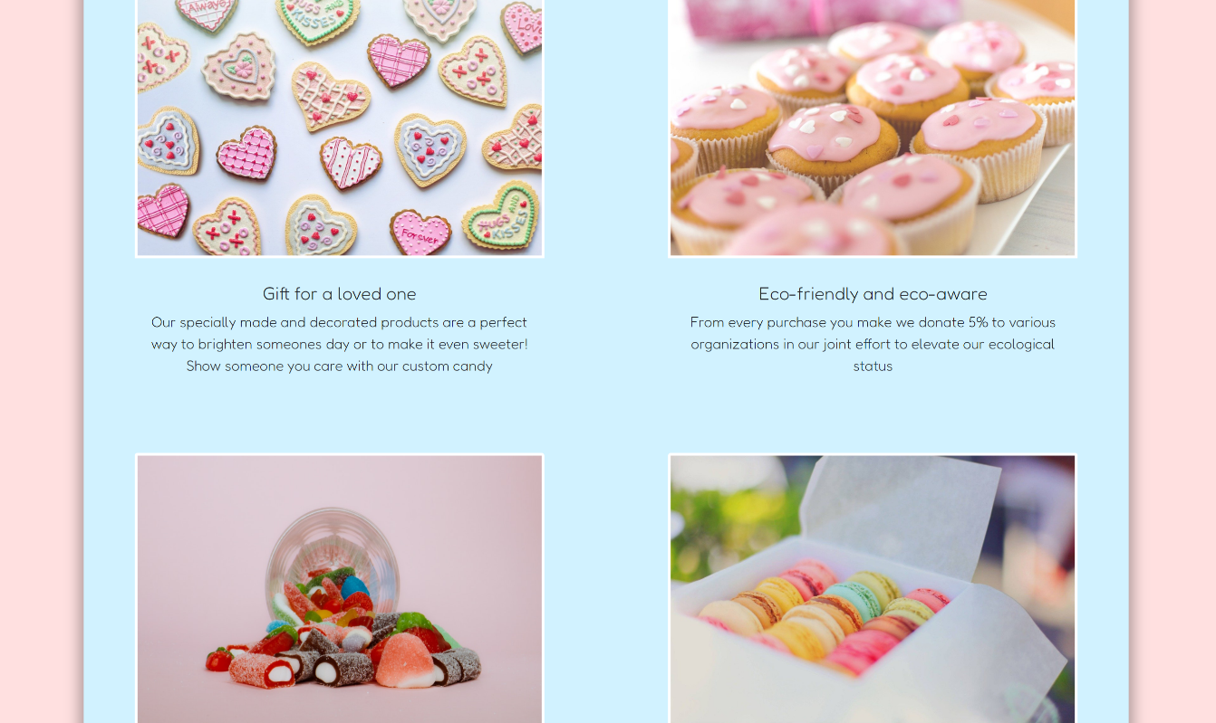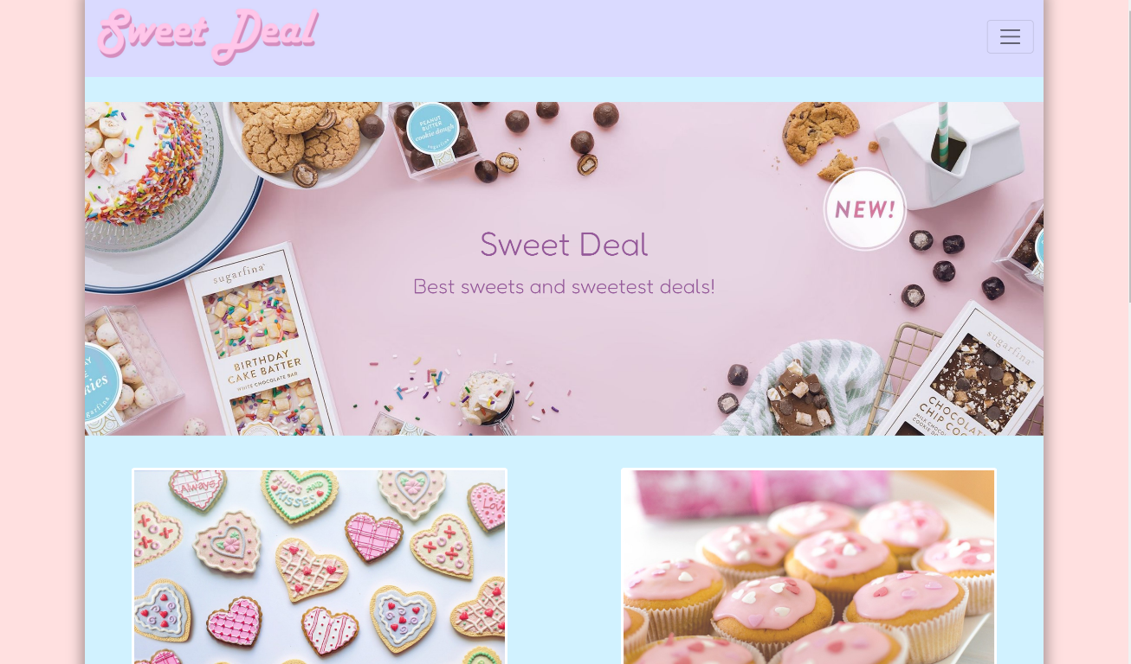

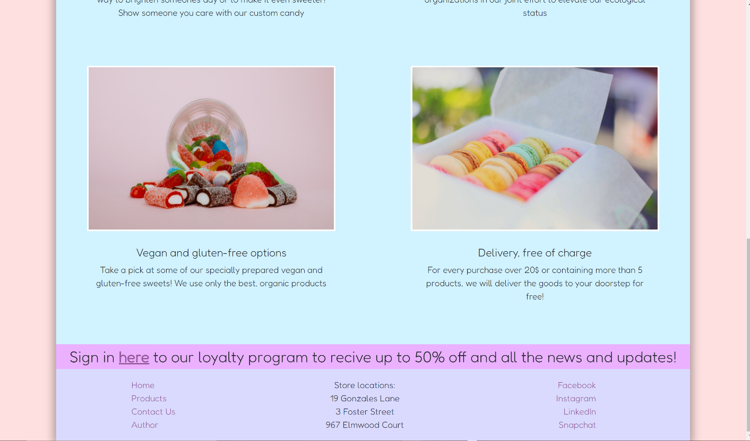

Stranica index.html

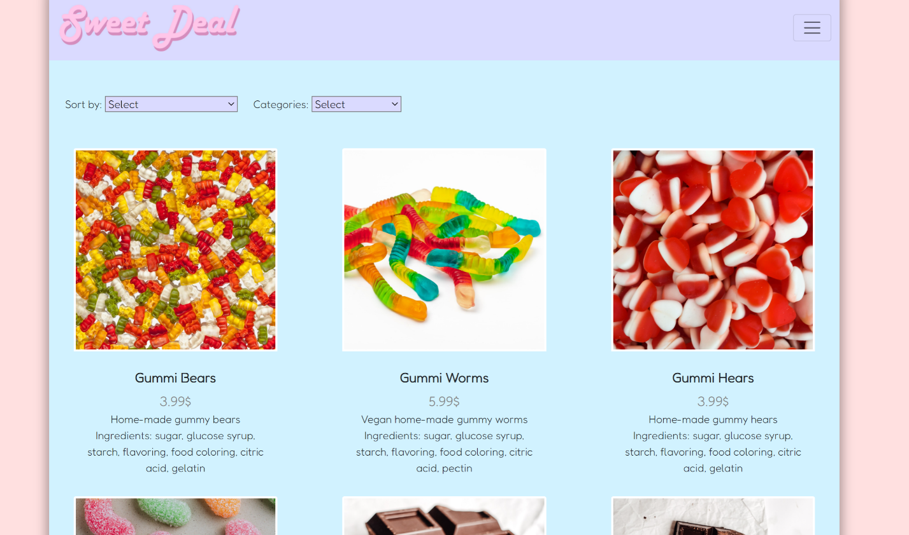

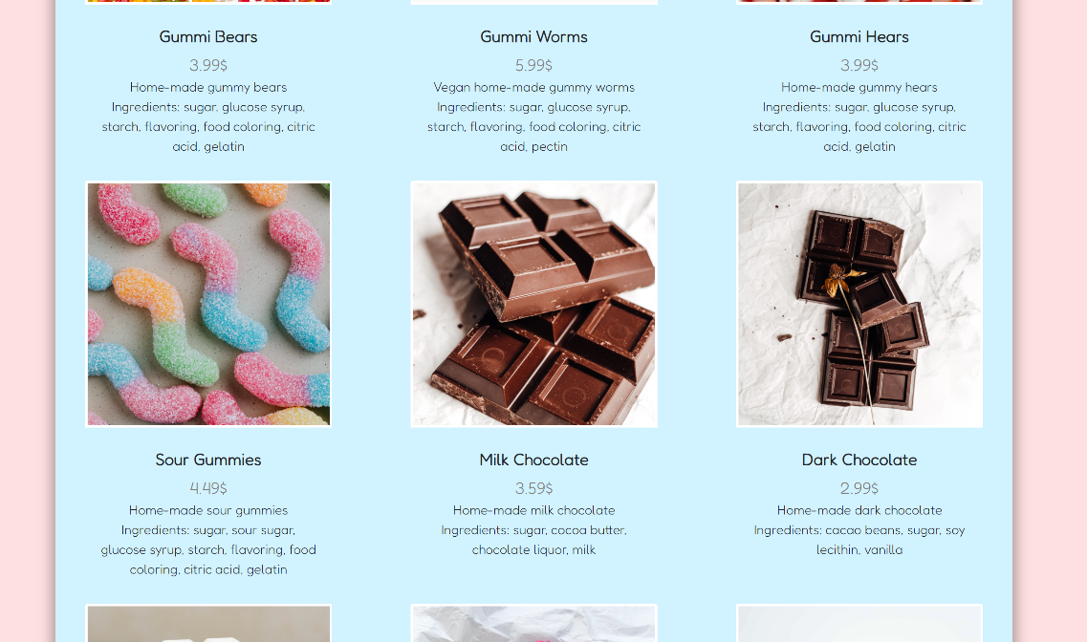

Stranica products.html I primer proizvoda

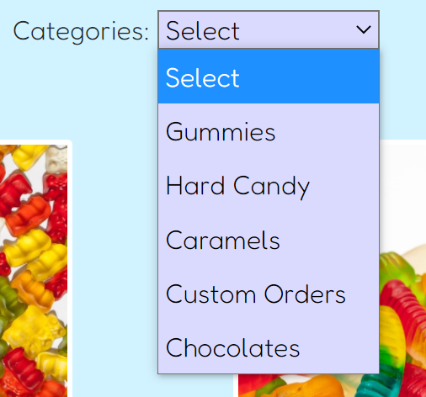

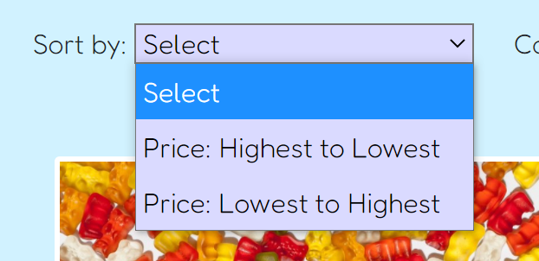

Sortiranje prema ceni I kategoriji

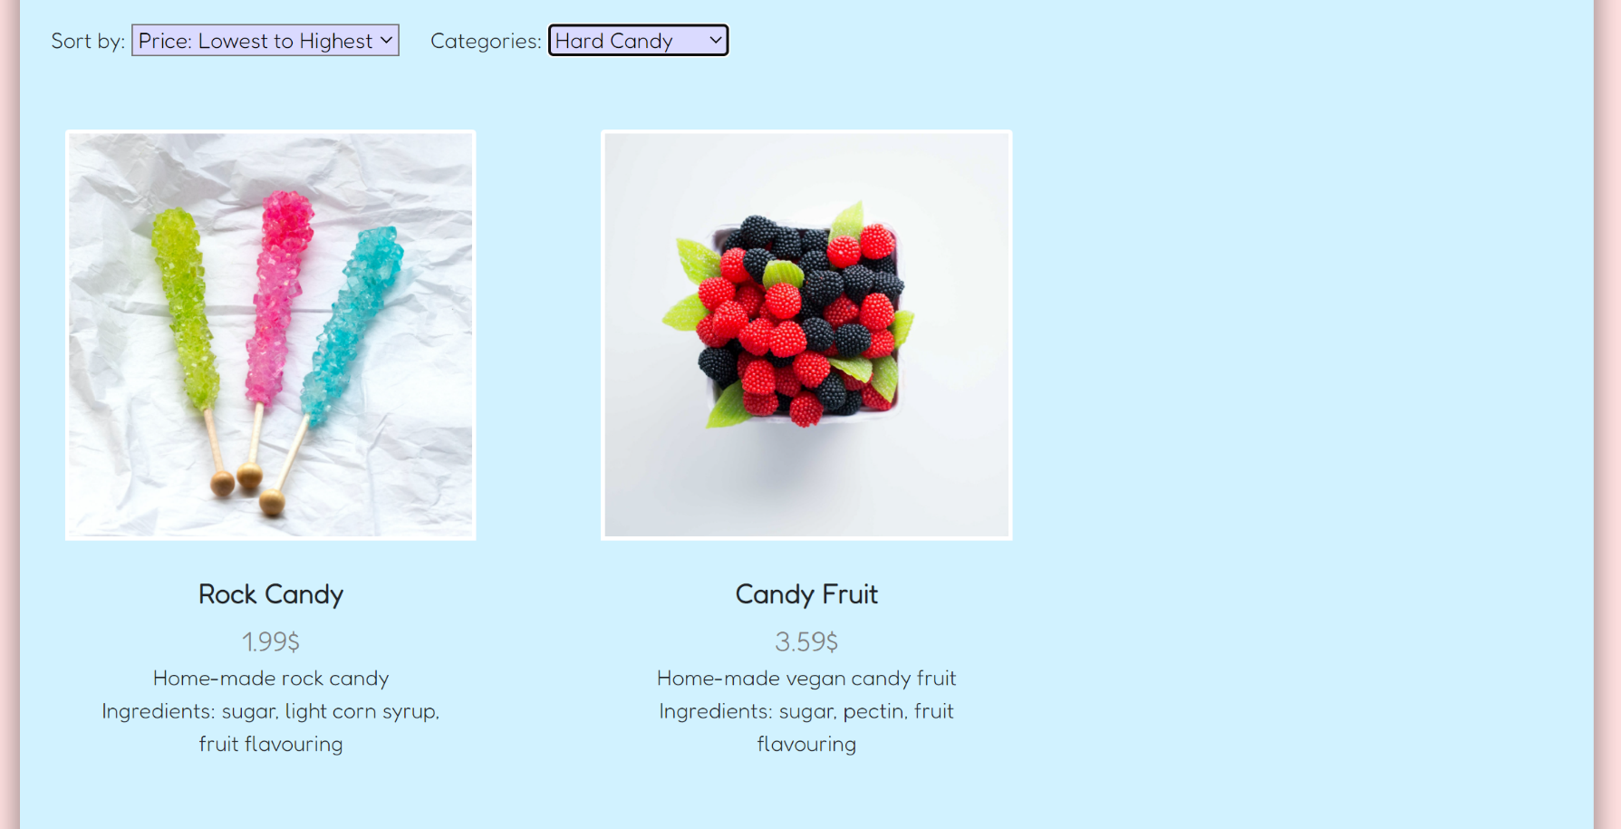

Prikaz forme, nepopunjene, neispravno I ispravno popunjene

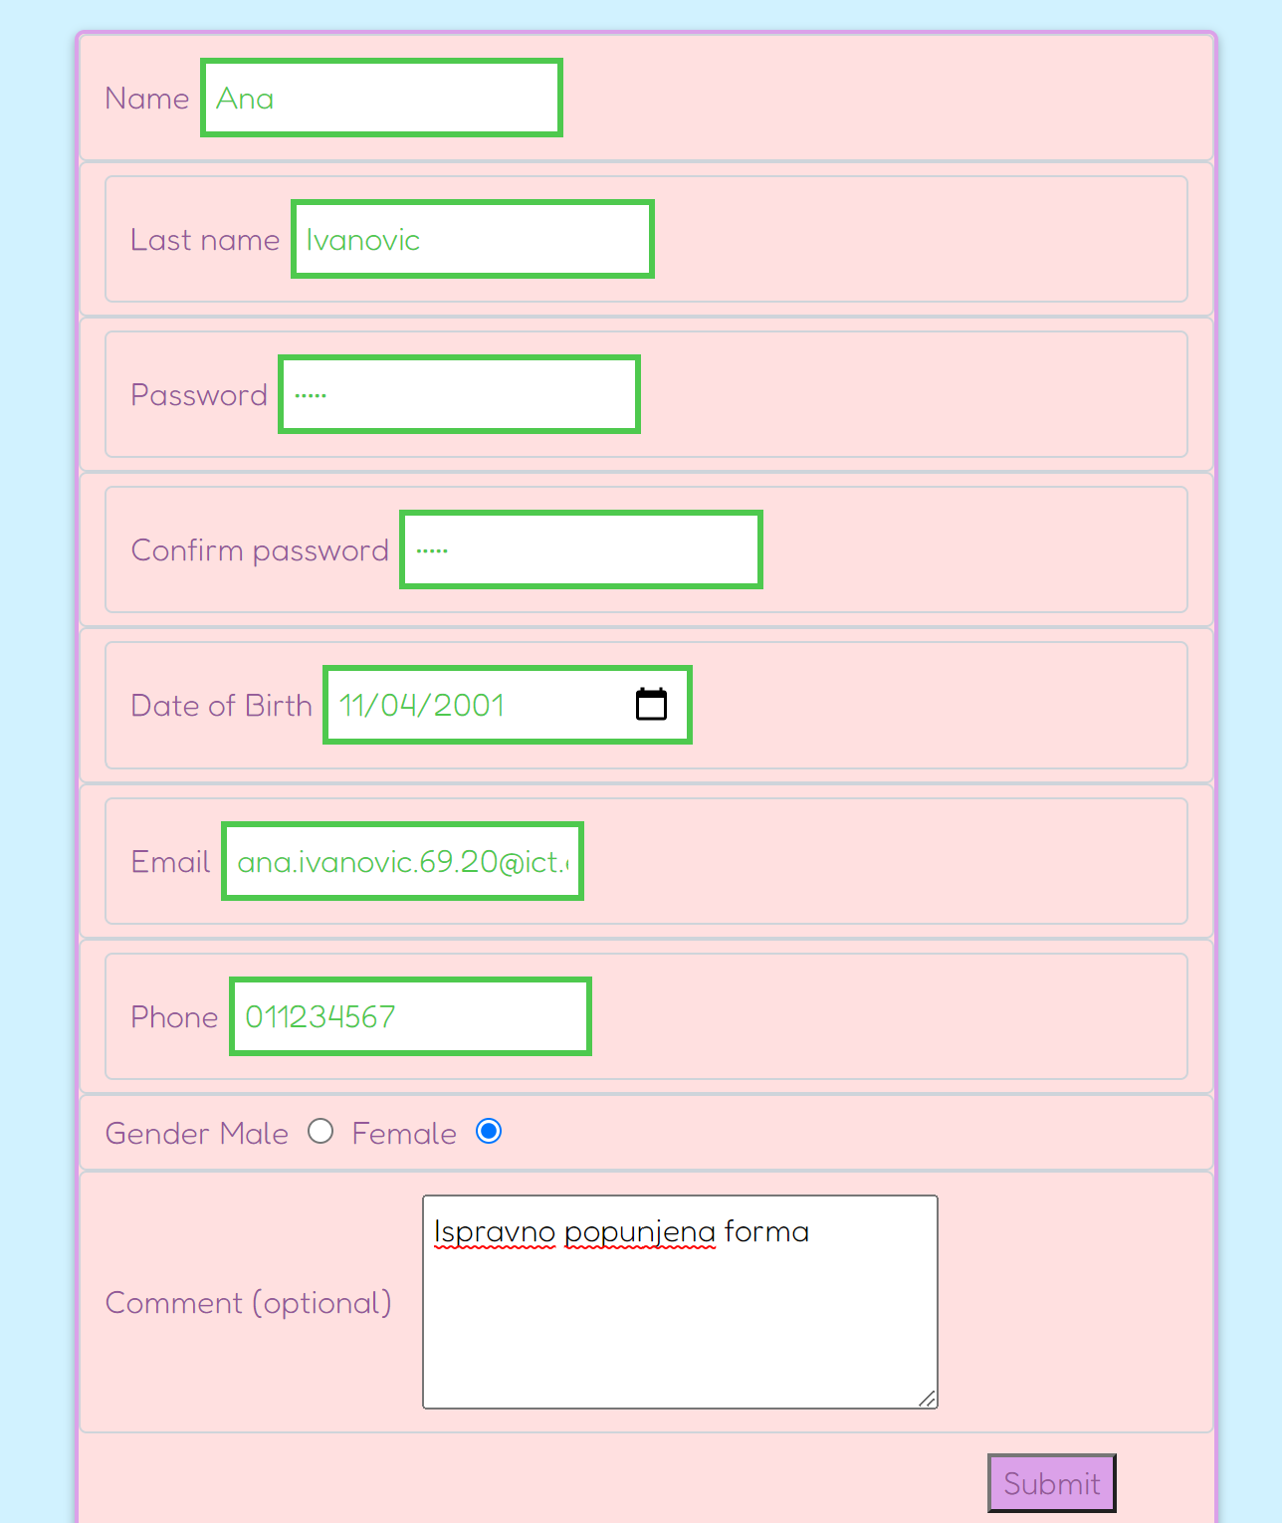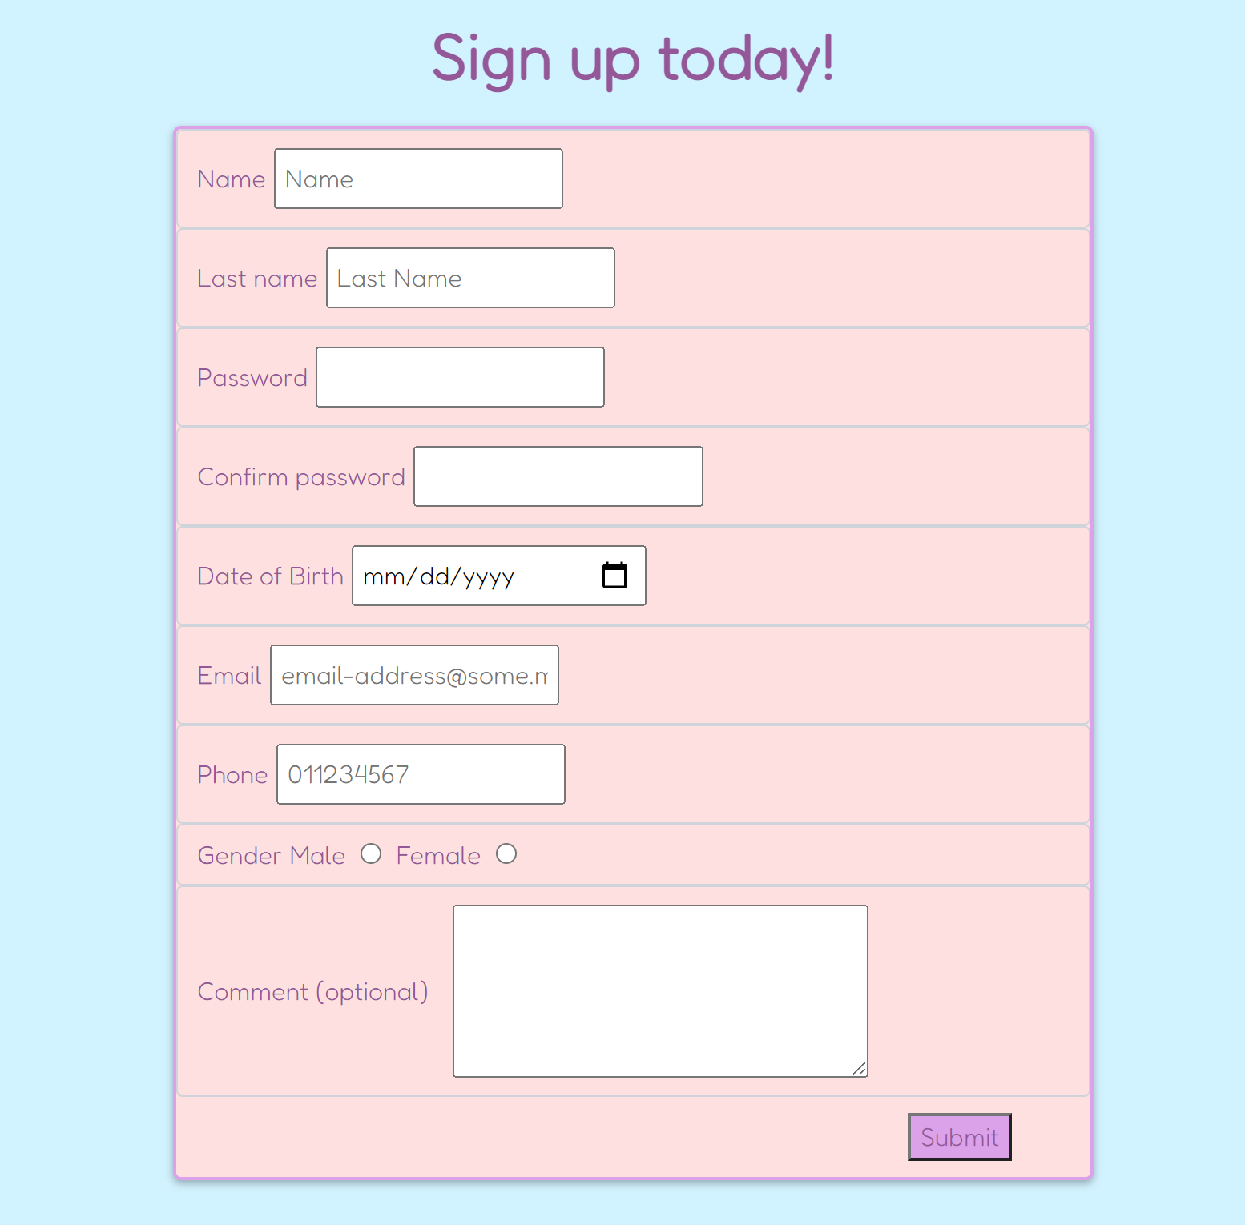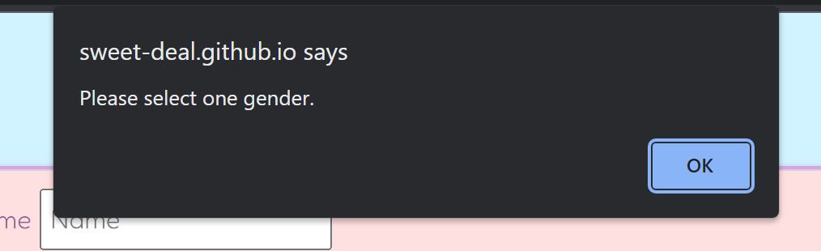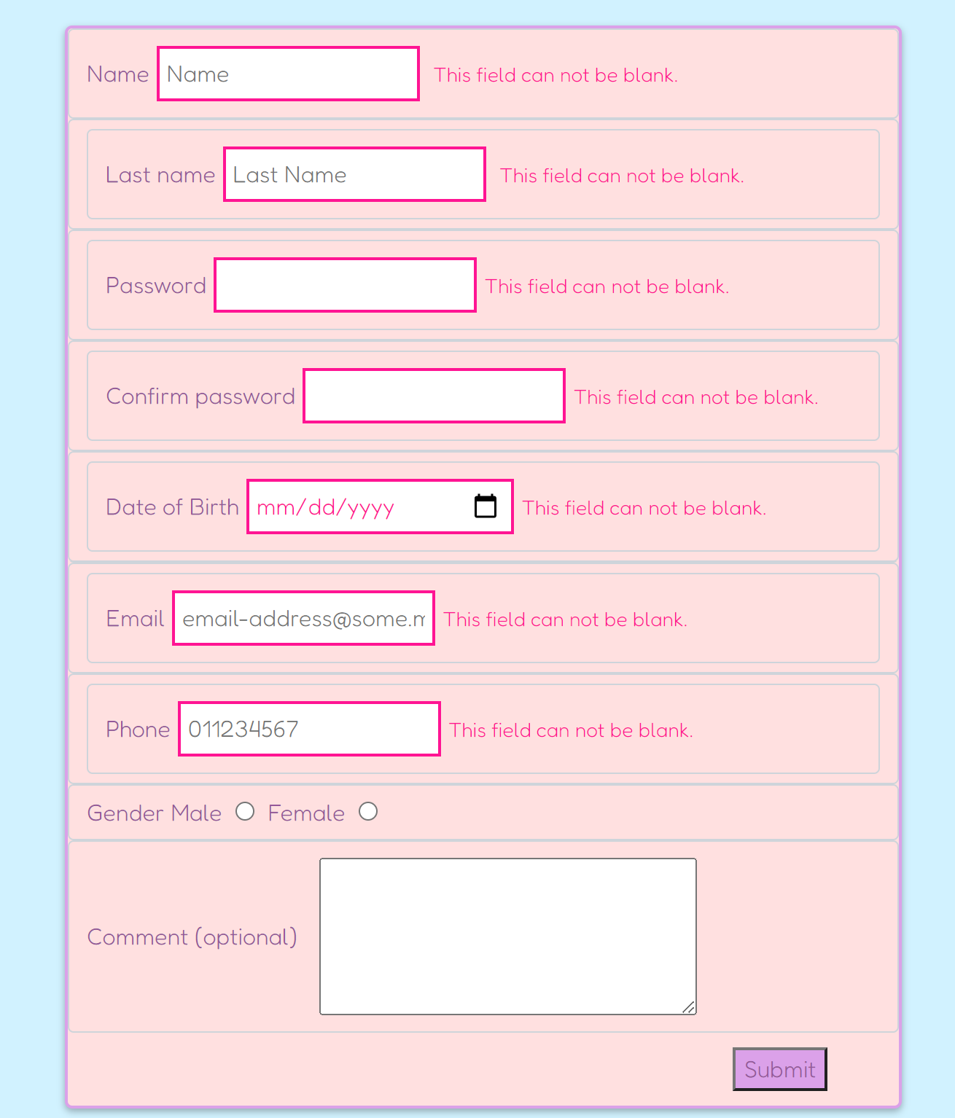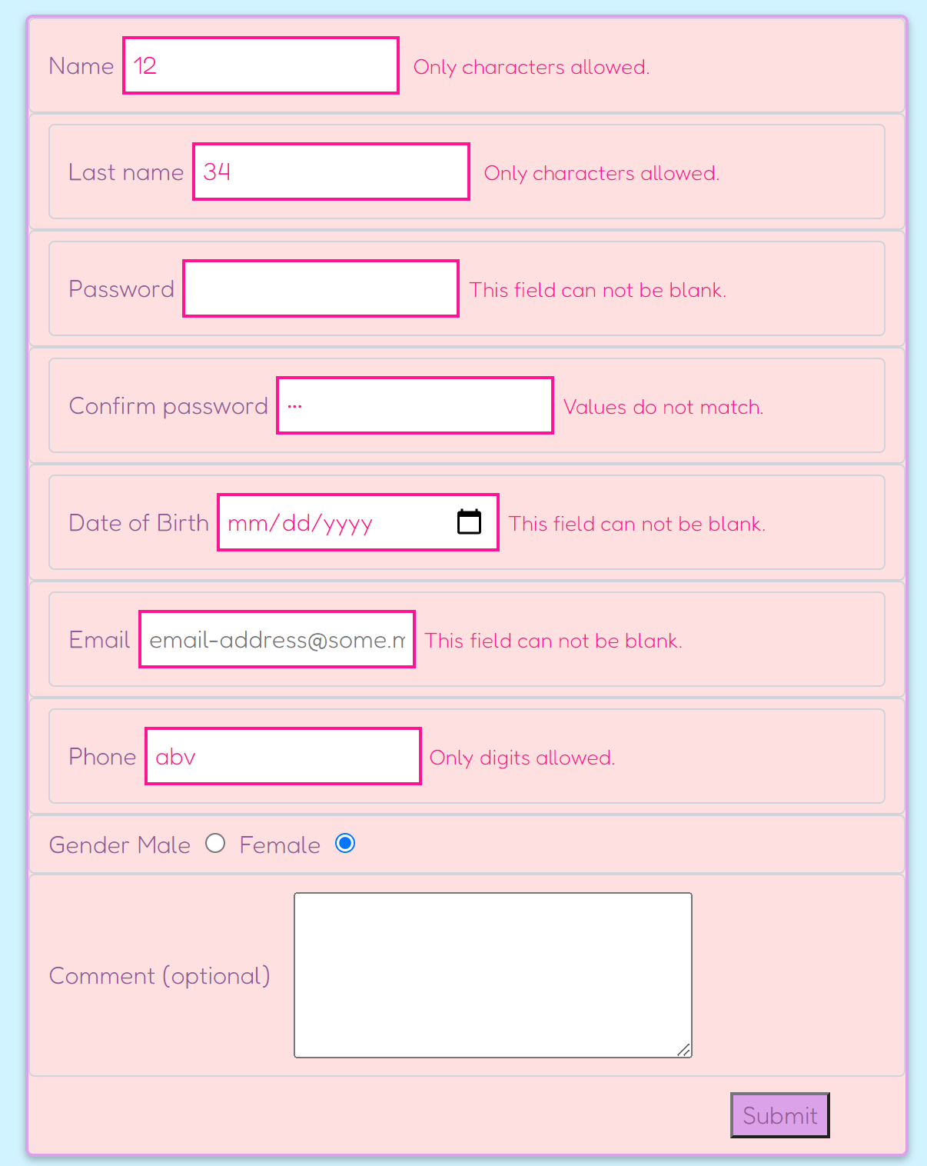

Stranica author.php

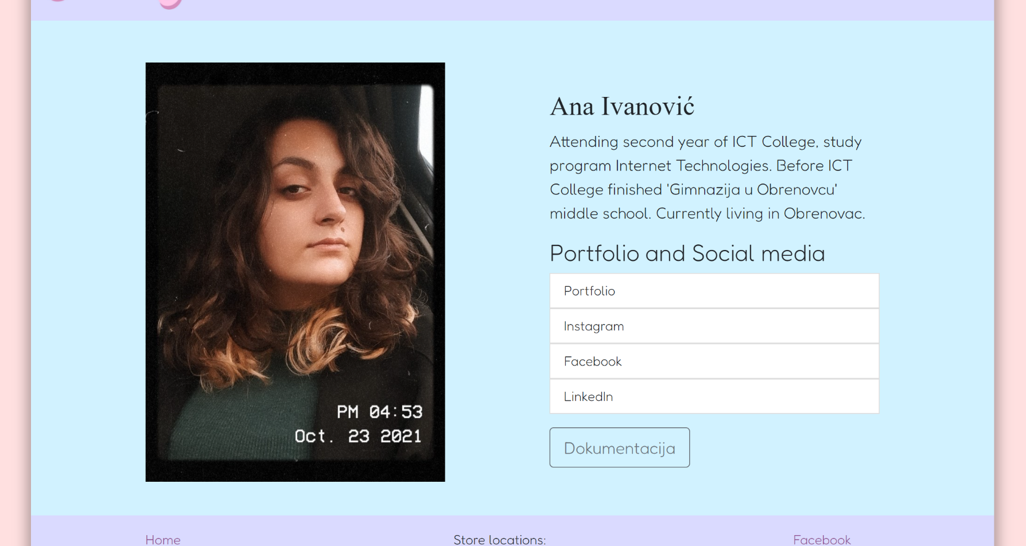

## HTML

KODOVI I SINTAKSA

Redom: index.php, products.php, contact.php, author.php

<!DOCTYPE html>

<html>

<head>

    <link rel="stylesheet" href="assets/css/style.css" />

    <meta name="viewport" content="width=device-width, initial-scale=1.0" />

    <meta name="description" content="Online local candy shop">

    <meta name="keywords" content="sweets, candy, sugar, gummy, vegan, gluten-free, ecofriendly, caramel, chocolate">

    <link href="https://cdn.jsdelivr.net/npm/bootstrap@5.1.3/dist/css/bootstrap.min.css" rel="stylesheet"

        integrity="sha384-1BmE4kWBq78iYhFldvKuhfTAU6auU8tT94WrHftjDbrCEXSU1oBoqyl2QvZ6jIW3" crossorigin="anonymous" />

    <link rel="stylesheet" href="https://cdnjs.cloudflare.com/ajax/libs/font-awesome/4.7.0/css/font-awesome.min.css">

</head>

  <body>

    <div class="main-container">

    <header>

      <nav class="navbar navbar-light bg-light">

        <div class="container-fluid logo">

          <a href="index.html"><img src="assets/images/logocs.jpg" alt="Sweet Deal" class="logo-img navbar-brand"></a>

          <button class="navbar-toggler" type="button" data-bs-toggle="offcanvas" data-bs-target="#offcanvasNavbar"

            aria-controls="offcanvasNavbar">

            <span class="navbar-toggler-icon"></span>

          </button>

          <div class="offcanvas offcanvas-end" tabindex="-1" id="offcanvasNavbar" aria-labelledby="offcanvasNavbarLabel">

            <div class="offcanvas-header">

              <h5 class="offcanvas-title" id="offcanvasNavbarLabel">Sweet Deal</h5>

              <button type="button" class="btn-close text-reset" data-bs-dismiss="offcanvas" aria-label="Close"></button>

            </div>

            <div class="offcanvas-body" id="nav-meni">

            </div>

          </div>

        </div>

      </nav>

    </header>

    <div class="container-banner">

      <div class="textbox">

        <h1 class="banner-main">Sweet Deal</h1>

        <p class="banner-text">Best sweets and sweetest deals!</p>

      </div>

    </div>

    <div class="container-rows-4">

      <div class="row row-cols-1 row-cols-md-2 g-4" id="index-cards">

      </div>

    </div><div class="container-subscribe">

      <h3>Sign in <b><a href="contact-us.html" class="subscribe">here</a></b> to our loyalty program to recive up to 50% off and all the

        news and updates! </h3>

    </div>

    <footer>

      <div class="container-footer">

        <nav class="nav-footer" id="nav-meni-futer">

        </nav>

      </div>

      <div class="container-footer">

        <div class="contact">

          <ul>

            <li>Store locations:</li>

            <li>19 Gonzales Lane</li>

            <li>3 Foster Street</li>

            <li>967 Elmwood Court</li>

          </ul>

        </div>

      </div>

      <div class="container-footer">

        <div class="social-list" id="socials">

          <h5>You can find our socials here:</h5>

        </div>

      </div>

    </footer>

    </div>

    <script src="https://cdn.jsdelivr.net/npm/bootstrap@5.0.2/dist/js/bootstrap.bundle.min.js"

    integrity="sha384-MrcW6ZMFYlzcLA8Nl+NtUVF0sA7MsXsP1UyJoMp4YLEuNSfAP+JcXn/tWtIaxVXM" crossorigin="anonymous"></script>

    <script src="https://cdn.jsdelivr.net/npm/bootstrap@5.0.2/dist/js/bootstrap.bundle.min.js"

    integrity="sha384-MrcW6ZMFYlzcLA8Nl+NtUVF0sA7MsXsP1UyJoMp4YLEuNSfAP+JcXn/tWtIaxVXM" crossorigin="anonymous"></script>

    <script src="http://ajax.googleapis.com/ajax/libs/jquery/1.9.1/jquery.min.js"></script>

    <script src="assets/js/indexcardAjax.js"></script>

    <script src="assets/js/mainAjax.js"></script>

    <!--<script src="assets/js/main.js"></script>

    <script src="assets/js/indexcard.js"></script>-->

  </body>

</html>

<!DOCTYPE html>

<html>

<head>

    <link rel="stylesheet" href="assets/css/style.css" />

    <meta name="viewport" content="width=device-width, initial-scale=1.0" />

    <meta name="description" content="Online local candy shop">

    <meta name="keywords" content="sweets, candy, sugar, gummy, vegan, gluten-free, ecofriendly, caramel, chocolate">

    <link href="https://cdn.jsdelivr.net/npm/bootstrap@5.1.3/dist/css/bootstrap.min.css" rel="stylesheet"

        integrity="sha384-1BmE4kWBq78iYhFldvKuhfTAU6auU8tT94WrHftjDbrCEXSU1oBoqyl2QvZ6jIW3" crossorigin="anonymous" />

    <link rel="stylesheet" href="https://cdnjs.cloudflare.com/ajax/libs/font-awesome/4.7.0/css/font-awesome.min.css">

</head>

<body>

    <div class="main-container">

        <header>

            <nav class="navbar navbar-light bg-light">

                <div class="container-fluid logo">

                    <a href="index.html"><img src="assets/images/logocs.jpg" alt="Sweet Deal"

                            class="logo-img navbar-brand"></a>

                    <button class="navbar-toggler" type="button" data-bs-toggle="offcanvas"

                        data-bs-target="#offcanvasNavbar" aria-controls="offcanvasNavbar">

                        <span class="navbar-toggler-icon"></span>

                    </button>

                    <div class="offcanvas offcanvas-end" tabindex="-1" id="offcanvasNavbar"

                        aria-labelledby="offcanvasNavbarLabel">

                        <div class="offcanvas-header">

                            <h5 class="offcanvas-title" id="offcanvasNavbarLabel">Sweet Deal</h5>

                            <button type="button" class="btn-close text-reset" data-bs-dismiss="offcanvas"

                                aria-label="Close"></button>

                        </div>

                        <div class="offcanvas-body" id="nav-meni">

                        </div>

                    </div>

                </div>

            </nav>

        </header>

            <div class="kategorisanje-sortiranje">

                <div id="sortiranje">

                </div>

                <div id="kategorije">

                </div>

            </div>

            <div class="proizvodi">

                <div class="row row-cols-1 row-cols-md-3 g-4" id="proizvod">

                </div>

        </div>

        <footer>

            <div class="container-footer">

                <nav class="nav-footer" id="nav-meni-futer">

                </nav>

            </div>

            <div class="container-footer">

                <div class="contact">

                    <ul>

                        <li>Store locations:</li>

                        <li>19 Gonzales Lane</li>

                        <li>3 Foster Street</li>

                        <li>967 Elmwood Court</li>

                    </ul>

                </div>

            </div>

            <div class="container-footer">

                <div class="social-list" id="socials">

                    <h5>You can find our socials here:</h5>

                </div>

            </div>

        </footer>

        </div>

        <script src="https://cdn.jsdelivr.net/npm/bootstrap@5.0.2/dist/js/bootstrap.bundle.min.js"

            integrity="sha384-MrcW6ZMFYlzcLA8Nl+NtUVF0sA7MsXsP1UyJoMp4YLEuNSfAP+JcXn/tWtIaxVXM"

            crossorigin="anonymous"></script>

        <script src="http://ajax.googleapis.com/ajax/libs/jquery/1.9.1/jquery.min.js"></script>

        <script src="assets/js/proizvodAjax.js"></script>

        <script src="assets/js/mainAjax.js"></script>

        <!--<script src="assets/js/main.js"></script>

        <script src="assets/js/proizvod.js"></script>-->

        </body>

        </html>

<!DOCTYPE html>

<html>

<head>

    <link rel="stylesheet" href="assets/css/style.css" />

    <meta name="viewport" content="width=device-width, initial-scale=1.0" />

    <meta name="description" content="Online local candy shop">

    <meta name="keywords" content="sweets, candy, sugar, gummy, vegan, gluten-free, ecofriendly, caramel, chocolate">

    <link href="https://cdn.jsdelivr.net/npm/bootstrap@5.1.3/dist/css/bootstrap.min.css" rel="stylesheet"

        integrity="sha384-1BmE4kWBq78iYhFldvKuhfTAU6auU8tT94WrHftjDbrCEXSU1oBoqyl2QvZ6jIW3" crossorigin="anonymous" />

    <link rel="stylesheet" href="https://cdnjs.cloudflare.com/ajax/libs/font-awesome/4.7.0/css/font-awesome.min.css">

</head>

<body>

    <div class="main-container">

        <header>

            <nav class="navbar navbar-light bg-light">

                <div class="container-fluid logo">

                    <a href="index.html"><img src="assets/images/logocs.jpg" alt="Sweet Deal"

                            class="logo-img navbar-brand"></a>

                    <button class="navbar-toggler" type="button" data-bs-toggle="offcanvas"

                        data-bs-target="#offcanvasNavbar" aria-controls="offcanvasNavbar">

                        <span class="navbar-toggler-icon"></span>

                    </button>

                    <div class="offcanvas offcanvas-end" tabindex="-1" id="offcanvasNavbar"

                        aria-labelledby="offcanvasNavbarLabel">

                        <div class="offcanvas-header">

                            <h5 class="offcanvas-title" id="offcanvasNavbarLabel">Sweet Deal</h5>

                            <button type="button" class="btn-close text-reset" data-bs-dismiss="offcanvas"

                                aria-label="Close"></button>

                        </div>

                        <div class="offcanvas-body" id="nav-meni">

                        </div>

                    </div>

                </div>

            </nav>

        </header>

        <h1 class="h1Form">Sign up today!</h1>

        <div id="error"></div>

        <form id="form" name="form">

            <div class="form-control">

                <label for="fname">Name</label><input type="text" name="fname" maxlength="30" id="fname" placeholder="Name">

                <small>Error message</small>

            </div>

            <div class="form-control">

                <label for="lname">Last name<input type="text" name="lname" maxlength="30" id="lname" placeholder="Last Name">

                    <small>Error message</small>

            </div>

            <div class="form-control">

                <label for="password">Password<input type="password" name="password" id="password"><small>Error message</small>

            </div>

            <div class="form-control">

                <label for="password-con">Confirm password<input type="password" name="password-con" id="password-con"><small>Error message</small>

            </div>

            <div class="form-control">

                <label for="date">Date of Birth<input type="date" name="date" id="date"><small>Error message</small>

            </div>

            <div class="form-control">

                <label for="email">Email<input type="email" name="email" maxlength="100" placeholder="email-address@some.mail" id="email"><small>Error message</small>

            </div>

            <div class="form-control">

                <label for="phone">Phone<input type="text" name="phone" maxlength="10" placeholder="011234567" id="phone"><small>Error message</small>

            </div>

            <div class="form-control">

                <label for="gender" id="gender">Gender

                <label>Male <input type="radio" name="gender" value="male"></label>

                <label>Female <input type="radio" name="gender" value="female"></label>

            </div>

            <div class="form-control">

                <label for="comment" class="comment" id="comment">Comment (optional)<textarea name="comment" id="comment" cols="30" rows="4"></textarea>

            </div>

                        <button class="formBtn">Submit</button>

        </form>

<footer>

    <div class="container-footer">

        <nav class="nav-footer" id="nav-meni-futer">

        </nav>

    </div>

    <div class="container-footer">

        <div class="contact">

            <ul>

                <li>Store locations:</li>

                <li>19 Gonzales Lane</li>

                <li>3 Foster Street</li>

                <li>967 Elmwood Court</li>

            </ul>

        </div>

    </div>

    <div class="container-footer">

        <div class="social-list" id="socials">

            <h5>You can find our socials here:</h5>

        </div>

    </div>

</footer>

</div>

<script src="https://cdn.jsdelivr.net/npm/bootstrap@5.0.2/dist/js/bootstrap.bundle.min.js"

    integrity="sha384-MrcW6ZMFYlzcLA8Nl+NtUVF0sA7MsXsP1UyJoMp4YLEuNSfAP+JcXn/tWtIaxVXM"

    crossorigin="anonymous"></script>

<script src="http://ajax.googleapis.com/ajax/libs/jquery/1.9.1/jquery.min.js"></script>

<script src="assets/js/obradaforme.js"></script>

<script src="assets/js/mainAjax.js"></script>

<!--<script src="assets/js/main.js"></script>-->

</body>

</html>

<!DOCTYPE html>

<html>

<head>

    <link rel="stylesheet" href="assets/css/style.css" />

    <meta name="viewport" content="width=device-width, initial-scale=1.0" />

    <meta name="description" content="Online local candy shop">

    <meta name="keywords" content="sweets, candy, sugar, gummy, vegan, gluten-free, ecofriendly, caramel, chocolate">

    <link href="https://cdn.jsdelivr.net/npm/bootstrap@5.1.3/dist/css/bootstrap.min.css" rel="stylesheet"

        integrity="sha384-1BmE4kWBq78iYhFldvKuhfTAU6auU8tT94WrHftjDbrCEXSU1oBoqyl2QvZ6jIW3" crossorigin="anonymous" />

    <link rel="stylesheet" href="https://cdnjs.cloudflare.com/ajax/libs/font-awesome/4.7.0/css/font-awesome.min.css">

</head>

<body>

    <div class="main-container">

        <header>

            <nav class="navbar navbar-light bg-light">

                <div class="container-fluid logo">

                    <a href="index.html"><img src="assets/images/logocs.jpg" alt="Sweet Deal"

                            class="logo-img navbar-brand"></a>

                    <button class="navbar-toggler" type="button" data-bs-toggle="offcanvas"

                        data-bs-target="#offcanvasNavbar" aria-controls="offcanvasNavbar">

                        <span class="navbar-toggler-icon"></span>

                    </button>

                    <div class="offcanvas offcanvas-end" tabindex="-1" id="offcanvasNavbar"

                        aria-labelledby="offcanvasNavbarLabel">

                        <div class="offcanvas-header">

                            <h5 class="offcanvas-title" id="offcanvasNavbarLabel">Sweet Deal</h5>

                            <button type="button" class="btn-close text-reset" data-bs-dismiss="offcanvas"

                                aria-label="Close"></button>

                        </div>

                        <div class="offcanvas-body" id="nav-meni">

                        </div>

                    </div>

                </div>

            </nav>

        </header>

        <div class="container-fluid">

            <div class="rowautor">

                <div class="autor">

                    <img src="assets/images/me.jpeg" alt="Photo of me" class="rounded-lg">

                </div>

                <div class="opis-socials">

                    <div class="opis">

                        <h2 class="mt-3 h2Autor">

                            Ana Ivanović

                        </h2>

                        <p>Attending second year of ICT College, study program Internet Technologies. Before ICT College finished 'Gimnazija

                            u Obrenovcu' middle school. Currently living in Obrenovac.</p>

                    </div>

                    <div class="links d.flex justify-content-evenly align-items-center">

                        <h3>Portfolio and Social media</h3>

                        <ul class="list-group list-group-flush links">

                            <a href="https://portfolioana.github.io/" target="_blank">

                                <li class="list-group-item">Portfolio</li>

                            </a>

                            <a href="https://instagram.com/" target="_blank">

                                <li class="list-group-item">Instagram</li>

                            </a>

                            <a href="https://facebook.com/" target="_blank">

                                <li class="list-group-item">Facebook</li>

                            </a>

                            <a href="https://linkedin.com/" target="_blank">

                                <li class="list-group-item">LinkedIn</li>

                            </a>

                        </ul>

                    </div>

                    <a href="assets/dokumentacija.pdf" class="btn btn-outline-secondary btn-lg mt-3">Dokumentacija</a>

                </div>

            </div>

        </div>

<footer>

    <div class="container-footer">

        <nav class="nav-footer" id="nav-meni-futer">

        </nav>

    </div>

    <div class="container-footer">

        <div class="contact">

            <ul>

                <li>Store locations:</li>

                <li>19 Gonzales Lane</li>

                <li>3 Foster Street</li>

                <li>967 Elmwood Court</li>

            </ul>

        </div>

    </div>

    <div class="container-footer">

        <div class="social-list" id="socials">

            <h5>You can find our socials here:</h5>

        </div>

    </div>

</footer>

</div>

<script src="https://cdn.jsdelivr.net/npm/bootstrap@5.0.2/dist/js/bootstrap.bundle.min.js"

    integrity="sha384-MrcW6ZMFYlzcLA8Nl+NtUVF0sA7MsXsP1UyJoMp4YLEuNSfAP+JcXn/tWtIaxVXM"

    crossorigin="anonymous"></script>

<script src="http://ajax.googleapis.com/ajax/libs/jquery/1.9.1/jquery.min.js"></script>

<script src="assets/js/mainAjax.js"></script>

<!--<script src="assets/js/main.js"></script>-->

</body>

</html>

## CSS

1. @import url("https://fonts.googleapis.com/css2?family=Modak&display=swap");
2. @import url("https://fonts.googleapis.com/css2?family=Fredoka:wght@300&display=swap");
3. :root {
4. --pink: #fcc4ec;
5. --blue: #d1f2ff;
6. --cream: #ffe0e0;
7. --lavander: #dadaff;
8. --magenta: #ebb1ff;
9. --darkerpink: #dba1e9;
10. --darkpurple: #945899;
11. }
12. body {
13. background-color: var(--cream) !important;
14. margin: 0px auto;
15. font-family: "Fredoka", sans-serif !important;
16. }
17. #nav-meni li a {
18. text-decoration: none;
19. }
20. .main-container {
21. width: 85%;
22. margin-right: auto;
23. margin-left: auto;
24. background-color: var(--blue);
25. box-shadow: 0px 0px 15px 5px rgba(0, 0, 0, 0.3);
26. }
27. .logo img {
28. height: 80px;
29. }
30. .navbar.navbar-light.bg-light {
31. background-color: var(--lavander) !important;
32. font-family: "Modak", cursive;
33. }
34. .offcanvas-body {
35. color: var(--darkpurple) !important;
36. }
37. .offcanvas-body {
38. background-color: var(--lavander);
39. padding: 0px !important;
40. }
41. .offcanvas-body ul {
42. list-style: none;
43. width: 100%;
44. padding: 10px 0px;
45. text-align: center;
46. font-size: 20px;
47. }
48. .offcanvas-body a,
49. .offcanvas-body li {
50. text-decoration: none;
51. color: var(--darkpurple);
52. width: 100%;
53. }
54. .offcanvas-body a:hover,
55. .offcanvas-body li:hover {
56. color: var(--lavander);
57. background-color: var(--darkpurple);
58. }
59. #offcanvasNavbarLabel {
60. font-size: 30px;
61. }
62. .offcanvas-header {
63. background-color: var(--darkpurple);
64. color: var(--lavander);
65. }
66. .modal-backdrop.show {
67. opacity: 0;
68. display: none !important;
69. }
70. .container-banner {
71. background-image: url(../images/CandyShop.jpg);
72. height: 400px;
73. background-size: cover;
74. display: flex;
75. align-items: center;
76. justify-content: center;
77. text-align: center;
78. margin-top: 30px;
79. color: var(--darkpurple);
80. }
81. p.banner-text {
82. font-size: 25px;
83. }
84. .col {
85. width: 40%;
86. margin-top: 30px;
87. margin-bottom: 40px;
88. }
89. .col img {
90. height: 300px;
91. border: 3px solid #fff;
92. width: inherit;
93. }
94. .card {
95. width: 450px;
96. margin: auto;
97. border: none !important;
98. background-clip: border-box;
99. align-items: center;
100. }
101. .card-body {
102. text-align: center;
103. background-color: var(--blue);
104. height: 150px;
105. }
106. .card-title {
107. font-size: 20px;
108. margin-top: 10px;
109. margin-bottom: 15px;
110. }
111. .container-subscribe {
112. background-color: var(--magenta);
113. text-align: center;
114. margin-top: 15px;
115. margin-bottom: 0px;
116. height: 45px;
117. display: flex;
118. align-items: center;
119. justify-content: center;
120. }
121. .row.row-cols-1.row-cols-md-2.g-4 {
122. margin-top: 15px;
123. }
124. .container-subscribe h3 {
125. margin-bottom: 0px;
126. margin-top: 0px;
127. }
128. .subscribe {
129. color: var(--darkpurple);
130. }
131. .container-subscribe {
132. margin-bottom: -25px;
133. }
134. .container-subscribe a:hover {
135. color: black;
136. }
137. footer {
138. background-color: var(--lavander);
139. margin-top: 25px;
140. display: flex;
141. justify-content: space-between;
142. align-items: center;
143. }
144. .container-footer {
145. display: flex;
146. justify-content: center;
147. align-items: center;
148. width: 400px;
149. height: 130px;
150. padding-right: 30px;
151. }
152. .container-footer ul {
153. padding: 0px;
154. margin: 0px;
155. text-decoration: none;
156. list-style: none;
157. }
158. .container-footer a li {
159. color: var(--darkpurple);
160. text-decoration: none;
161. }
162. footer a {
163. text-decoration: none !important;
164. }
165. footer a:hover,
166. footer li:hover {
167. color: #000 !important;
168. }
169. .nav-footer {
170. text-align: left;
171. /*margin-right: 30px;*/
172. }
173. .contact {
174. text-align: center;
175. }
176. .social-list {
177. text-align: right;
178. /*margin-right: 30px;*/
179. }
180. .kategorisanje-sortiranje {
181. display: flex;
182. justify-content: flex-start;
183. align-items: center;
184. height: 130px;
185. padding-left: 2%;
186. }
187. #kategorije {
188. margin-left: 2%;
189. }
190. .proizvod {
191. width: 300px;
192. justify-content: center;
193. align-items: center;
194. }
195. .card-body {
196. width: 100%;
197. }
198. button,
199. select {
200. background-color: var(--lavander);
201. }
202. .price {
203. font-size: 20px;
204. color: #808080;
205. }
206. .col-md-5 {
207. background-color: var(--blue) !important;
208. }
209. .mb-3 {
210. width: 100%;
211. max-width: unset;
212. }
213. .beginnings {
214. display: flex;
215. margin-top: 40px;
216. }
217. .h1Form {
218. font-weight: bold;
219. text-align: center;
220. color: var(--darkpurple);
221. margin-top: 40px;
222. margin-bottom: 20px;
223. }
224. form {
225. color: var(--darkpurple);
226. background-color: var(--cream);
227. border-collapse: collapse;
228. border: 2px solid var(--darkerpink);
229. width: 50%;
230. margin-left: 25%;
231. margin-bottom: 40px;
232. border-radius: 5px;
233. box-shadow: 0 2px 5px rgba(0, 0, 0, 0.3);
234. max-width: 100%;
235. }
236. .form-control {
237. color: var(--darkpurple) !important;
238. background-color: rgba(255, 224, 224, 0.2) !important;
239. }
240. .form-control small {
241. visibility: hidden;
242. }
243. .formBtn {
244. background-color: var(--darkerpink);
245. color: var(--darkerpurle);
246. margin: 10px 10px 10px 80% !important;
247. }
248. .formBtn:hover {
249. background-color: var(--darkpurple);
250. color: var(--lavander);
251. }
252. .form-control input {
253. padding: 5px;
254. margin: 5px;
255. }
256. .form-control textarea {
257. padding: 5px;
258. margin: 5px 15px;
259. }
260. .comment {
261. display: flex;
262. align-items: center;
263. }
264. .error input {
265. border: 2px solid #ff1493;
266. color: #ff1493;
267. }
268. .success input {
269. border: 3px solid #4ec94e;
270. color: #4ec94e;
271. }
272. .form-control.error small {
273. visibility: visible !important;
274. color: #ff1493;
275. }
276. .autor:hover {
277. box-shadow: 0 12px 16px 0 rgba(0, 0, 0, 0.24),
278. 0 17px 50px 0 rgba(0, 0, 0, 0.19);
279. }
280. .autor img {
281. height: 500px;
282. width: -moz-available;
283. }
284. .opis-socials {
285. width: 35%;
286. }
287. .rowautor {
288. display: flex;
289. justify-content: space-evenly;
290. align-items: center;
291. margin-top: 50px;
292. margin-bottom: 40px;
293. }
294. .mt-3.h2Autor {
295. font-family: initial;
296. }
297. .opis p {
298. font-size: 19px;
299. }
300. .links a,
301. .links li {
302. text-decoration: none;
303. }
304. @media only screen and (max-width: 1201px) {
305. .nav-header a {
306. font-size: 25px;
307. }
308. .logo img {
309. height: 65px;
310. }
311. .col img {
312. height: 275px;
313. }
314. .card-body {
315. width: 425px;
316. }
317. .container-subscribe h3 {
318. font-size: 23px;
319. }
320. }
321. @media only screen and (max-width: 1111px) {
322. .nav-header a {
323. font-size: 20px;
324. }
325. .logo img {
326. height: 60px;
327. }
328. .col img {
329. height: 250px;
330. width: 400px;
331. }
332. .card-body {
333. width: 400px;
334. }
335. .proizvod-img {
336. height: 400px !important;
337. }
338. }
339. @media only screen and (max-width: 1025px) {
340. .main-container {
341. width: 100%;
342. }
343. .nav-header a {
344. font-size: 23px;
345. }
346. .card {
347. width: auto;
348. }
349. .row {
350. margin-right: 0px !important;
351. }
352. }
353. @media only screen and (max-width: 850px) {
354. .col {
355. width: 100%;
356. display: flex;
357. align-items: center;
358. justify-content: center;
359. }
360. .container-two-rows {
361. display: unset;
362. }
363. header {
364. justify-content: space-between;
365. }
366. .container-subscribe h3 {
367. font-size: 20px;
368. }
369. }
370. @media only screen and (max-width: 600px) {
371. .container-subscribe h3 {
372. font-size: 16px;
373. }
374. .rowautor {
375. display: unset;
376. }
377. .autor img {
378. width: auto;
379. margin: auto;
380. }
381. .opis-socials {
382. width: unset;
383. text-align: center;
384. }
385. .autor {
386. display: flex;
387. padding-top: 50px;
388. }
389. footer {
390. height: 200px;
391. }
392. }

## JavaScript

//AJAX i JSON kod, u delovima

//mainAjax.js

    $.ajax({

        url: "assets/js/data/navMeni.json",

        method: "get",

        dataType: "json",

        success: function(data){

            console.log(data);

            ispisListiLinkova(data);

            ispisListiLinkovaFuter(data);

        },

        error: function(xhr){

            console.log(xhr);

        }

    })

    $.ajax({

        url: "assets/js/data/social.json",

        method: "get",

        dataType: "json",

        success: function(data){

            ispisSocial(data);

        },

        error: function(xhr){

            console.log(xhr);

        }

    })

function ispisListiLinkova (podaci){

    let html = `<ul>`;

    for (let li of podaci){

        html += `<a href="${li.href}"><li>${li.naziv}</li></a>`;

    }

    html += `</ul>`;

    $("#nav-meni").html(html);

}

function ispisListiLinkovaFuter (podaci){

    let html = `<ul>`;

    for (let li of podaci){

        html += `<a href="${li.href}"><li>${li.naziv}</li></a>`;

    }

    html += `</ul>`;

    $("#nav-meni-futer").html(html);

}

function ispisSocial (podaci){

    let html = `<ul>`;

    for (let li of podaci){

        html += `<a href="${li.href}"><li>${li.naziv}</li></a>`;

    }

    html += `</ul>`;

    $("#socials").html(html);

}

//proizvodAjax.js

window.onload = function(){

    $.ajax({

        url: "assets/js/data/proizvodi.json",

        method: "get",

        dataType: "json",

        success: function(data){

            ispisProizvoda(data);

        },

        error: function(xhr){

            console.log(xhr);

        }

    })

    $.ajax({

        url: "assets/js/data/kategorije.json",

        method: "get",

        dataType: "json",

        success: function(data){

            padajucaLista(data, "#kategorije", "ddlKategorije", "Categories:");

        },

        error: function(xhr){

            console.log(xhr);

        }

    })

    $.ajax({

        url: "assets/js/data/sortiranje.json",

        method: "get",

        dataType: "json",

        success: function(data){

            padajucaLista(data, "#sortiranje", "ddlSort", "Sort by:");

        },

        error: function(xhr){

            console.log(xhr);

        }

    })

    $(document).on("change", "#ddlKategorije", function(){

        let idKat = $("#ddlKategorije").val();

        let filtriraniProizvodi = [];

        if (idKat == 0) {

            ispisProizvoda(proizvodi);

        }

        else {

            for(let objP of proizvodi){

            if (idKat == objP.idKat){

                filtriraniProizvodi.push(objP);

            }

        }

        ispisProizvoda(filtriraniProizvodi);

        }

    })

    $(document).on("change", "#ddlSort", function(){

        let idSort = $("#ddlSort").val();

        if (idSort == 0) {

            ispisProizvoda(proizvodi);

        }

        else if (idSort == 1){

            proizvodi.sort(function(a,b) { return a.cena.valueOf() < b.cena.valueOf();});

            ispisProizvoda(proizvodi);

        }

        else if (idSort == 2) {

            proizvodi.sort(function(a,b) { return a.cena.valueOf() > b.cena.valueOf();});

            ispisProizvoda(proizvodi);

        }

    })

}

function ispisProizvoda(podaci){

    let proizvod = ``;

    if (podaci.length == 0){

        proizvod += `<p>No products are currently available.</p>`

    }

    else {

        for (let pr of podaci) {

        proizvod += `<div class="col">

                        <div class="card proizvod">

                            <img src="${pr.imgSrc}" class="card-img-top img-fluid proizvod-img" alt="${pr.naziv}">

                            <div class="card-body">

                                <h2 class="card-title"><b>${pr.naziv}</b></h5>

                                <p class="card-text"><span class=price>${pr.cena}$</span></br>${pr.tekst.opis}</br>Ingredients: ${pr.tekst.sastojci}</p>

                            </div>

                        </div>

                    </div>`

        }

    }

    $("#proizvod").html(proizvod);

}

function padajucaLista(podaci, idBloka, idListe, labelTxt) {

    let lista = `<div class="form-group">

    <label>${labelTxt}</label>

    <select id=${idListe}>>`

    for (let podatak of podaci){

       lista += `<option value="${podatak.id}">${podatak.naziv}</option>`;

    }

    lista += `</select></div>`

    $(idBloka).html(lista);

}

//indexcardAjax.js

    $.ajax({

        url: "assets/js/data/indexCard.json",

        method: "get",

        dataType: "json",

        success: function(data){

            console.log(data);

            ispisIndexCard(data);

        },

        error: function(xhr){

            console.log(xhr);

        }

    })

function ispisIndexCard(podaci){

    let html=``;

    for (let card of podaci){

        html += `<div class="col">

          <div class="card">

            <img src="${card.href}" class="card-img-top" alt="${card.naziv}" />

            <div class="card-body">

              <h5 class="card-title">${card.naziv}</h5>

              <p class="card-text">

                ${card.tekst}

              </p>

            </div>

          </div>

        </div>`

    }

    $("#index-cards").html(html);

}

//obradaforme.js

const form = document.getElementById('form');

const fname = document.getElementById('fname');

const lname = document.getElementById('lname');

const pass = document.getElementById('password');

const passCon = document.getElementById('password-con');

const date = document.getElementById('date');

const email = document.getElementById('email');

const phone = document.getElementById('phone');

const gender = document.getElementsByName('gender');

form.addEventListener('submit', (e) => {

    e.preventDefault();

    provera();

})

function provera(){

    const fnameValue = fname.value

    const lnameValue = lname.value

    const passValue = pass.value

    const passConValue = passCon.value

    const dateValue = date.value

    const emailValue = email.value

    const phoneValue = phone.value

    prazno(passValue, pass);

    prazno(dateValue, date);

    prazno(emailValue, email);

    slova(fnameValue, fname);

    slova(lnameValue, lname);

    brojevi(phoneValue, phone);

    emailProvera(emailValue, email);

    isti(passValue, passConValue, passCon);

    pol(gender);

}

function greska(input, message){

    const formControl = input.parentElement;

    const small = formControl.querySelector('small');

    small.innerText = message;

    formControl.className = 'form-control error';

}

function uspeh(input){

    const formControl = input.parentElement;

    formControl.className = 'form-control success';

}

function prazno(vrednostValue, vrednost) {

    if(vrednostValue === ""){

        greska(vrednost, 'This field can not be blank.')

    }

    else {

        uspeh(vrednost)

    }

}

function slova(vrednostValue, vrednost){

    if(!isNaN(vrednostValue)&& (vrednostValue !== "")){

        greska(vrednost, 'Only characters allowed.')

    }

    else {

        prazno(vrednostValue, vrednost)

    }

}

function brojevi(vrednostValue, vrednost){

    if(isNaN(vrednostValue)&&(vrednostValue !== "")){

        greska(vrednost, 'Only digits allowed.')

    }

    else {

        prazno(vrednostValue, vrednost)

    }

}

function emailProvera(vrednostValue, vrednost){

    var lastAtPos = vrednostValue.lastIndexOf('@');

    var lastDotPos = vrednostValue.lastIndexOf('.');

    if((lastAtPos > lastDotPos || lastAtPos < 0 || vrednostValue.indexOf('@@') == 1 || lastDotPos < 2 || (vrednostValue.length - lastDotPos) < 2) &&(vrednostValue !== "")){

        greska(vrednost, 'This email is not valid.')

    }

    else{

        prazno(vrednostValue, vrednost)

    }

}

function isti(vrednostValue1, vrednostValue2, vrednost){

    if (vrednostValue1 != vrednostValue2 &&(vrednostValue2 !== "")) {

        greska(vrednost, 'Values do not match.')

    }

    else {

        prazno(vrednostValue2, vrednost)

    }

}

function pol(vrednost){

    if (!(vrednost[0].checked || vrednost[1].checked)) {

        alert('Please select one gender.');

    }

}

//proizvodi.json

[

   {

      "id":1,

      "naziv":"Gummi Bears",

      "imgSrc":"assets/images/candy/gummi-bears.jpg",

      "cena":3.99,

      "idKat":1,

      "tekst":{

         "opis":"Home-made gummy bears",

         "sastojci":"sugar, glucose syrup, starch, flavoring, food coloring, citric acid, gelatin"

      }

   },

   {

      "id":2,

      "naziv":"Gummi Worms",

      "imgSrc":"assets/images/candy/gummi-worms.jpg",

      "cena":5.99,

      "idKat":1,

      "tekst":{

         "opis":"Vegan home-made gummy worms",

         "sastojci":"sugar, glucose syrup, starch, flavoring, food coloring, citric acid, pectin"

      }

   },

   {

      "id":3,

      "naziv":"Gummi Hears",

      "imgSrc":"assets/images/candy/gummi-hearts.jpg",

      "cena":3.99,

      "idKat":1,

      "tekst":{

         "opis":"Home-made gummy hears",

         "sastojci":"sugar, glucose syrup, starch, flavoring, food coloring, citric acid, gelatin"

      }

   },

   {

      "id":4,

      "naziv":"Sour Gummies",

      "imgSrc":"assets/images/candy/sour-gummies.jpg",

      "cena":4.49,

      "idKat":1,

      "tekst":{

         "opis":"Home-made sour gummies",

         "sastojci":"sugar, sour sugar, glucose syrup, starch, flavoring, food coloring, citric acid, gelatin"

      }

   },

   {

      "id":5,

      "naziv":"Milk Chocolate",

      "imgSrc":"assets/images/candy/milk-choco.jpg",

      "cena":3.59,

      "idKat":5,

      "tekst":{

         "opis":"Home-made milk chocolate",

         "sastojci":"sugar, cocoa butter, chocolate liquor, milk"

      }

   },

   {

      "id":6,

      "naziv":"Dark Chocolate",

      "imgSrc":"assets/images/candy/dark-choco.jpg",

      "cena":2.99,

      "idKat":5,

      "tekst":{

         "opis":"Home-made dark chocolate",

         "sastojci":"cacao beans, sugar, soy lecithin, vanilla"

      }

   },

   {

      "id":7,

      "naziv":"White Chocolate",

      "imgSrc":"assets/images/candy/white-choco.jpg",

      "cena":3.99,

      "idKat":5,

      "tekst":{

         "opis":"Home-made white chocolate",

         "sastojci":"sugar, cocoa butter, milk, vanilla, lecithin"

      }

   },

   {

      "id":8,

      "naziv":"Rock Candy",

      "imgSrc":"assets/images/candy/rock-candy.jpg",

      "cena":1.99,

      "idKat":2,

      "tekst":{

         "opis":"Home-made rock candy",

         "sastojci":"sugar, light corn syrup, fruit flavouring"

      }

   },

   {

      "id":9,

      "naziv":"Candy Fruit",

      "imgSrc":"assets/images/candy/candy-fruit.jpg",

      "cena":3.59,

      "idKat":2,

      "tekst":{

         "opis":"Home-made vegan candy fruit",

         "sastojci":"sugar, pectin, fruit flavouring"

      }

   },

   {

      "id":10,

      "naziv":"Light Caramel",

      "imgSrc":"assets/images/candy/light-caramel.jpg",

      "cena":3.99,

      "idKat":3,

      "tekst":{

         "opis":"Home-made vanilla caramel",

         "sastojci":"caster sugar, vanilla, milk"

      }

   },

   {

      "id":11,

      "naziv":"Chocolate Caramel",

      "imgSrc":"assets/images/candy/caramel-choco.jpg",

      "cena":3.49,

      "idKat":3,

      "tekst":{

         "opis":"Home-made vegan chocolate caramel",

         "sastojci":"caster sugar, cacao beans"

      }

   },

   {

      "id":12,

      "naziv":"Salted Caramel",

      "imgSrc":"assets/images/candy/salted-caramel.jpg",

      "cena":4.29,

      "idKat":3,

      "tekst":{

         "opis":"Home-made salted caramel",

         "sastojci":"caster sugar, vanilla, sea salt, milk"

      }

   },

   {

      "id":13,

      "naziv":"Caramel",

      "imgSrc":"assets/images/candy/caramel.jpg",

      "cena":2.99,

      "idKat":3,

      "tekst":{

         "opis":"Home-made caramel",

         "sastojci":"caster sugar"

      }

   },

   {

      "id":14,

      "naziv":"Your Hearts",

      "imgSrc":"assets/images/candy/your-hearts.jpg",

      "cena":5.99,

      "idKat":4,

      "tekst":{

         "opis":"Custom-made heart candy! Choose the lettering while ordering!",

         "sastojci":"unflavored gelatin, water, confectioner's sugar"

      }

   },

   {

      "id":15,

      "naziv":"Special Bar",

      "imgSrc":"assets/images/candy/special-bar.jpg",

      "cena":5.99,

      "idKat":4,

      "tekst":{

         "opis":"Custom-made dark chocolate! Choose the lettering while ordering!",

         "sastojci":"cacao beans, sugar, soy lecithin, vanilla"

      }

   }

]

//kategorije.json

[

        {   "id": 0,

            "naziv" : "Select"

        },

        {

            "id" : 1,

            "naziv" : "Gummies"

        },

        {

            "id" : 2,

            "naziv" : "Hard Candy"

        },

        {

            "id" : 3,

            "naziv" : "Caramels"

        },

        {

            "id" : 4,

            "naziv" : "Custom Orders"

        },

        {

            "id" : 5,

            "naziv" : "Chocolates"

        }

    ]

//sortiranje.json

[

        {   "id": 0,

            "naziv" : "Select"

        },

        {

            "id" : 1,

            "naziv" : "Price: Highest to Lowest"

        },

        {

            "id" : 2,

            "naziv" : "Price: Lowest to Highest"

        }

    ]

//social.json

[

        {

            "naziv" : "Facebook",

            "href" : "https://facebook.com"

        },

        {

            "naziv" : "Instagram",

            "href" : "https://instagram.com"

        },

        {

            "naziv" : "LinkedIn",

            "href" : "https://linkedin.com"

        },

        {

            "naziv" : "Snapchat",

            "href" : "https://snapchat.com"

        }

    ]

//nav-meni.json

[

        {

            "naziv" : "Home",

            "href" : "index.html"

        },

        {

            "naziv" : "Products",

            "href" : "products.html"

        },

        {

            "naziv" : "Contact Us",

            "href" : "contact.html"

        },

        {

            "naziv" : "Author",

            "href" : "author.html"

        }

    ]

//indexCard.json

[

    {

        "id" : 1,

        "href" : "assets/images/hearts.jpg",

        "naziv" : "Gift for a loved one",

        "tekst" : "Our specially made and decorated products are a perfect way to brighten someones day or to make it even sweeter! Show someone you care with our custom candy"

    },

    {

        "id" : 2,

        "href" : "assets/images/cupcakes.jpg",

        "naziv" : "Eco-friendly and eco-aware",

        "tekst" : "From every purchase you make we donate 5% to various organizations in our joint effort to elevate our ecological status"

    },

    {

        "id" : 3,

        "href" : "assets/images/gummies.jpg",

        "naziv" : "Vegan and gluten-free options",

        "tekst" : "Take a pick at some of our specially prepared vegan and gluten-free sweets! We use only the best, organic products"

    },

    {

        "id" : 4,

        "href" : "assets/images/macarons.jpg",

        "naziv" : "Delivery, free of charge",

        "tekst" : "For every purchase over 20$ or containing more than 5 products, we will deliver the goods to your doorstep for free!"

    }

]

//kod koji sam probala da iskoristim bez JSON-a ili AJAX-a

var navMeni, social, kategorije, sortiranje, proizvodi, ispisIndexCard;

window.onload = function(){

    navMeni = [

        {

            "naziv" : "Home",

            "href" : "index.html"

        },

        {

            "naziv" : "Products",

            "href" : "products.html"

        },

        {

            "naziv" : "Contact Us",

            "href" : "contact-us.html"

        },

        {

            "naziv" : "Author",

            "href" : "author.html"

        }

    ]

    social = [

        {

            "naziv" : "Facebook",

            "href" : "https://facebook.com"

        },

        {

            "naziv" : "Instagram",

            "href" : "https://instagram.com"

        },

        {

            "naziv" : "LinkedIn",

            "href" : "https://linkedin.com"

        },

        {

            "naziv" : "Snapchat",

            "href" : "https://snapchat.com"

        }

    ]

    kategorije = [

        {   "id": 0,

            "naziv" : "Select"

        },

        {

            "id" : 1,

            "naziv" : "Gummies"

        },

        {

            "id" : 2,

            "naziv" : "Hard Candy"

        },

        {

            "id" : 3,

            "naziv" : "Caramels"

        },

        {

            "id" : 4,

            "naziv" : "Custom Orders"

        },

        {

            "id" : 5,

            "naziv" : "Chocolates"

        }

    ]

    sortiranje = [

        {   "id": 0,

            "naziv" : "Select"

        },

        {

            "id" : 1,

            "naziv" : "Price: Highest to Lowest"

        },

        {

            "id" : 2,

            "naziv" : "Price: Lowest to Highest"

        }

    ]

    proizvodi = [

   {

      "id":1,

      "naziv":"Gummi Bears",

      "imgSrc":"assets/images/candy/gummi-bears.jpg",

      "cena":3.99,

      "idKat":1,

      "tekst":{

         "opis":"Home-made gummy bears",

         "sastojci":"sugar, glucose syrup, starch, flavoring, food coloring, citric acid, gelatin"

      }

   },

   {

      "id":2,

      "naziv":"Gummi Worms",

      "imgSrc":"assets/images/candy/gummi-worms.jpg",

      "cena":5.99,

      "idKat":1,

      "tekst":{

         "opis":"Vegan home-made gummy worms",

         "sastojci":"sugar, glucose syrup, starch, flavoring, food coloring, citric acid, pectin"

      }

   },

   {

      "id":3,

      "naziv":"Gummi Hears",

      "imgSrc":"assets/images/candy/gummi-hearts.jpg",

      "cena":3.99,

      "idKat":1,

      "tekst":{

         "opis":"Home-made gummy hears",

         "sastojci":"sugar, glucose syrup, starch, flavoring, food coloring, citric acid, gelatin"

      }

   },

   {

      "id":4,

      "naziv":"Sour Gummies",

      "imgSrc":"assets/images/candy/sour-gummies.jpg",

      "cena":4.49,

      "idKat":1,

      "tekst":{

         "opis":"Home-made sour gummies",

         "sastojci":"sugar, sour sugar, glucose syrup, starch, flavoring, food coloring, citric acid, gelatin"

      }

   },

   {

      "id":5,

      "naziv":"Milk Chocolate",

      "imgSrc":"assets/images/candy/milk-choco.jpg",

      "cena":3.59,

      "idKat":5,

      "tekst":{

         "opis":"Home-made milk chocolate",

         "sastojci":"sugar, cocoa butter, chocolate liquor, milk"

      }

   },

   {

      "id":6,

      "naziv":"Dark Chocolate",

      "imgSrc":"assets/images/candy/dark-choco.jpg",

      "cena":2.99,

      "idKat":5,

      "tekst":{

         "opis":"Home-made dark chocolate",

         "sastojci":"cacao beans, sugar, soy lecithin, vanilla"

      }

   },

   {

      "id":7,

      "naziv":"White Chocolate",

      "imgSrc":"assets/images/candy/white-choco.jpg",

      "cena":3.99,

      "idKat":5,

      "tekst":{

         "opis":"Home-made white chocolate",

         "sastojci":"sugar, cocoa butter, milk, vanilla, lecithin"

      }

   },

   {

      "id":8,

      "naziv":"Rock Candy",

      "imgSrc":"assets/images/candy/rock-candy.jpg",

      "cena":1.99,

      "idKat":2,

      "tekst":{

         "opis":"Home-made rock candy",

         "sastojci":"sugar, light corn syrup, fruit flavouring"

      }

   },

   {

      "id":9,

      "naziv":"Candy Fruit",

      "imgSrc":"assets/images/candy/candy-fruit.jpg",

      "cena":3.59,

      "idKat":2,

      "tekst":{

         "opis":"Home-made vegan candy fruit",

         "sastojci":"sugar, pectin, fruit flavouring"

      }

   },

   {

      "id":10,

      "naziv":"Light Caramel",

      "imgSrc":"assets/images/candy/light-caramel.jpg",

      "cena":3.99,

      "idKat":3,

      "tekst":{

         "opis":"Home-made vanilla caramel",

         "sastojci":"caster sugar, vanilla, milk"

      }

   },

   {

      "id":11,

      "naziv":"Chocolate Caramel",

      "imgSrc":"assets/images/candy/caramel-choco.jpg",

      "cena":3.49,

      "idKat":3,

      "tekst":{

         "opis":"Home-made vegan chocolate caramel",

         "sastojci":"caster sugar, cacao beans"

      }

   },

   {

      "id":12,

      "naziv":"Salted Caramel",

      "imgSrc":"assets/images/candy/salted-caramel.jpg",

      "cena":4.29,

      "idKat":3,

      "tekst":{

         "opis":"Home-made salted caramel",

         "sastojci":"caster sugar, vanilla, sea salt, milk"

      }

   },

   {

      "id":13,

      "naziv":"Caramel",

      "imgSrc":"assets/images/candy/caramel.jpg",

      "cena":2.99,

      "idKat":3,

      "tekst":{

         "opis":"Home-made caramel",

         "sastojci":"caster sugar"

      }

   },

   {

      "id":14,

      "naziv":"Your Hearts",

      "imgSrc":"assets/images/candy/your-hearts.jpg",

      "cena":5.99,

      "idKat":4,

      "tekst":{

         "opis":"Custom-made heart candy! Choose the lettering while ordering!",

         "sastojci":"unflavored gelatin, water, confectioner's sugar"

      }

   },

   {

      "id":15,

      "naziv":"Special Bar",

      "imgSrc":"assets/images/candy/special-bar.jpg",

      "cena":5.99,

      "idKat":4,

      "tekst":{

         "opis":"Custom-made dark chocolate! Choose the lettering while ordering!",

         "sastojci":"cacao beans, sugar, soy lecithin, vanilla"

      }

   }

]

    indexCard = [

        {

            "id" : 1,

            "href" : "assets/images/hearts.jpg",

            "naziv" : "Gift for a loved one",

            "tekst" : "Our specially made and decorated products are a perfect way to brighten someones day or to make it even sweeter! Show someone you care with our custom candy"

        },

        {

            "id" : 2,

            "href" : "assets/images/cupcakes.jpg",

            "naziv" : "Eco-friendly and eco-aware",

            "tekst" : "From every purchase you make we donate 5% to various organizations in our joint effort to elevate our ecological status"

        },

        {

            "id" : 3,

            "href" : "assets/images/gummies.jpg",

            "naziv" : "Vegan and gluten-free options",

            "tekst" : "Take a pick at some of our specially prepared vegan and gluten-free sweets! We use only the best, organic products"

        },

        {

            "id" : 4,

            "href" : "assets/images/macarons.jpg",

            "naziv" : "Delivery, free of charge",

            "tekst" : "For every purchase over 20$ or containing more than 5 products, we will deliver the goods to your doorstep for free!"

        }

    ]

    this.ispisIndexCard(indexCard, "#index-cards");

    this.ispisListiLinkova(navMeni, "#nav-meni");

    this.ispisListiLinkova(navMeni, "#nav-meni-futer");

    this.ispisListiLinkova(social, "#socials");

    this.padajucaLista(kategorije, "#kategorije", "ddlKategorije", "Categories:");

    this.padajucaLista(sortiranje, "#sortiranje", "ddlSort", "Sort by:");

    this.ispisProizvoda(proizvodi, "#proizvod");

    $(document).on("change", "#ddlKategorije", function(){

        let idKat = $("#ddlKategorije").val();

        let filtriraniProizvodi = [];

        if (idKat == 0) {

            ispisProizvoda(proizvodi, "#proizvod");

        }

        else {

            for(let objP of proizvodi){

            if (idKat == objP.idKat){

                filtriraniProizvodi.push(objP);

            }

        }

        ispisProizvoda(filtriraniProizvodi, "#proizvod");

        }

    })

    $(document).on("change", "#ddlSort", function(){

        let idSort = $("#ddlSort").val();

        if (idSort == 0) {

            ispisProizvoda(proizvodi, "#proizvod");

        }

        else if (idSort == 1){

            proizvodi.sort(function(a,b) { return a.cena.valueOf() < b.cena.valueOf();});

            ispisProizvoda(proizvodi, "#proizvod");

        }

        else if (idSort == 2) {

            proizvodi.sort(function(a,b) { return a.cena.valueOf() > b.cena.valueOf();});

            ispisProizvoda(proizvodi, "#proizvod");

        }

    })

}

function ispisListiLinkova (podaci, idBloka){

    let html = `<ul>`;

    for (let li of podaci){

        html += `<a href="${li.href}"><li>${li.naziv}</li></a>`;

    }

    html += `</ul>`;

    $(idBloka).html(html);

}

function padajucaLista(podaci, idBloka, idListe, labelTxt) {

    let lista = `<div class="form-group">

    <label>${labelTxt}</label>

    <select id=${idListe}>>`

    for (let podatak of podaci){

       lista += `<option value="${podatak.id}">${podatak.naziv}</option>`;

    }

    lista += `</select></div>`

    $(idBloka).html(lista);

}

function ispisProizvoda(podaci, idBloka) {

    let proizvod = ``;

    if (podaci.length == 0){

        proizvod += `<p>No products are currently available.</p>`

    }

    else {

        for (let pr of podaci) {

        proizvod += `<div class="col">

                        <div class="card proizvod">

                            <img src="${pr.imgSrc}" class="card-img-top img-fluid proizvod-img" alt="${pr.naziv}">

                            <div class="card-body">

                                <h2 class="card-title"><b>${pr.naziv}</b></h5>

                                <p class="card-text"><span class=price>${pr.cena}$</span></br>${pr.tekst.opis}</br>Ingredients: ${pr.tekst.sastojci}</p>

                            </div>

                        </div>

                    </div>`

    }

    }

    $(idBloka).html(proizvod);

}

function ispisIndexCard(podaci, idBloka){

    let html=``;

    for (let card of podaci){

        html += `<div class="col">

          <div class="card">

            <img src="${card.href}" class="card-img-top" alt="${card.naziv}" />

            <div class="card-body">

              <h5 class="card-title">${card.naziv}</h5>

              <p class="card-text">

                ${card.tekst}

              </p>

            </div>

          </div>

        </div>`

    }

    $(idBloka).html(html);

}

///// obrada forme

const form = document.getElementById('form');

const fname = document.getElementById('fname');

const lname = document.getElementById('lname');

const pass = document.getElementById('password');

const passCon = document.getElementById('password-con');

const date = document.getElementById('date');

const email = document.getElementById('email');

const phone = document.getElementById('phone');

const gender = document.getElementsByName('gender');

form.addEventListener('submit', (e) => {

    e.preventDefault();

    provera();

})

function provera(){

    const fnameValue = fname.value

    const lnameValue = lname.value

    const passValue = pass.value

    const passConValue = passCon.value

    const dateValue = date.value

    const emailValue = email.value

    const phoneValue = phone.value

    prazno(passValue, pass);

    prazno(dateValue, date);

    prazno(emailValue, email);

    slova(fnameValue, fname);

    slova(lnameValue, lname);

    brojevi(phoneValue, phone);

    emailProvera(emailValue, email);

    isti(passValue, passConValue, passCon);

    pol(gender);

}

function greska(input, message){

    const formControl = input.parentElement;

    const small = formControl.querySelector('small');

    small.innerText = message;

    formControl.className = 'form-control error';

}

function uspeh(input){

    const formControl = input.parentElement;

    formControl.className = 'form-control success';

}

function prazno(vrednostValue, vrednost) {

    if(vrednostValue === ""){

        greska(vrednost, 'This field can not be blank.')

    }

    else {

        uspeh(vrednost)

    }

}

function slova(vrednostValue, vrednost){

    if(!isNaN(vrednostValue)&& (vrednostValue !== "")){

        greska(vrednost, 'Only characters allowed.')

    }

    else {

        prazno(vrednostValue, vrednost)

    }

}

function brojevi(vrednostValue, vrednost){

    if(isNaN(vrednostValue)&&(vrednostValue !== "")){

        greska(vrednost, 'Only digits allowed.')

    }

    else {

        prazno(vrednostValue, vrednost)

    }

}

function emailProvera(vrednostValue, vrednost){

    var lastAtPos = vrednostValue.lastIndexOf('@');

    var lastDotPos = vrednostValue.lastIndexOf('.');

    if((lastAtPos > lastDotPos || lastAtPos < 0 || vrednostValue.indexOf('@@') == 1 || lastDotPos < 2 || (vrednostValue.length - lastDotPos) < 2) &&(vrednostValue !== "")){

        greska(vrednost, 'This email is not valid.')

    }

    else{

        prazno(vrednostValue, vrednost)

    }

}

function isti(vrednostValue1, vrednostValue2, vrednost){

    if (vrednostValue1 != vrednostValue2 &&(vrednostValue2 !== "")) {

        greska(vrednost, 'Values do not match.')

    }

    else {

        prazno(vrednostValue2, vrednost)

    }

}

function pol(vrednost){

    if (!(vrednost[0].checked || vrednost[1].checked)) {

        alert('Please select one gender.');

    }

}